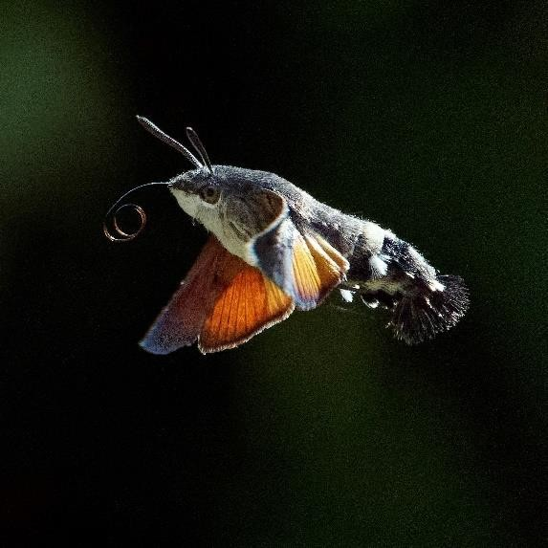
PHOTOGRAPHING THE NATURAL WORLD OF KINGCOMBE
Taught by Paul Williams, author and professional photographer.
Tues 5th – Thur 7th May 2020

This new course will be a mixture of talks,
demonstrations and fieldwork, based around the Kingcombe and Powerstock Common area. It will include tips, techniques and ideas for improving your photography of flowers, insects, habitats and birds.

This course will combine both practical outdoor photography on the reserves supported with linked theory sessions in our teaching studio. Any theory session will be followed by a chance to go out and put it into practice, return, debrief and revisit as necessary. Paul will always be on hand to look at images on your cameras and help you understand where you may be going wrong or what it is you are doing right. The course is certainly open to beginners and mixed ability. One of the main aims of the course is achieving replicability with the focus around achieving a good image time after time rather than one good one amongst weaker images.

On your first evening we will explore what the course will offer whilst Paul will also get an idea of your skillset and the goals you have whilst on the course. Later you will look at the exposure triangle and the pros and cons of being in manual mode along with some basic composition rules. You will be taught low-level light photography, macro and birds in flight, how to use depth of field to your advantage and long exposure. Paul will make the most of the morning and evening light conditions and explore the reserve so that ample opportunity is given to take that perfect shot.

Following dinner on Wednesday evening Paul will take the opportunity to talk about his own personal journey and how photographing the natural world can undoubtedly improve your own health and well- being. Paul will also show some examples of his own fantastic work from around the world.

Paul Williams was born in the lake district, a place that very early on fostered his life-long love for all things outdoors. At the age of seventeen he joined the army where he served for 17 years until a serious climbing accident brought his career to a halt forcing him to consider the direction his life should take. Having recently lost several comrades to suicide he decided to become a mental health specialist and graduated with a first class honours degree in mental health nursing. After three years working in Assertive Outreach Paul realised he was missing the adrenaline that had been his drug of choice since he was a teenager and joined Dorset Police. In 2010 Paul had to disarm a samurai sword-wielding lady with just his pepper spray as she tried to attack members of the public in a police station. Although he thought nothing of it at the time, he very quickly became unwell and was diagnosed with Post Traumatic Stress Disorder (PTSD). Several suicide attempts later Paul found himself at a personal crossroads where he had to choose to fight his illness or give in to it. Thankfully a new therapy gave him a window of relatively stable mental health during which he picked up his camera after years of barely using it. Starting with shots taken in his garden Paul gradually built up the confidence to leave his house and go further afield. He discovered a family of barn owls at Dorset Wildlife Trust's (DWT) reserve over at Lorton
Image credit: Paul Williams

Meadows and spent much of that summer capturing the family as they battled for survival. The resulting images were used by the trust and were well received on social media leading to him gradually rebuild what had been shattered self-confidence.

Further improvements in Paul’s mental health followed, along with more media exposure, and a growing number of magazines and Countryfile and BBC radio took an interest in his story of early recovery. From those early, tentative steps towards wellbeing Paul has now progressed to travelling around the world taking breath- taking images in Sweden, Norway, the Arctic and Alaska as well as the UK. He's released his first book with a very positive review by Chris Packham, and has given several presentations on mental and physical wellbeing and the power of photography and nature to heal even the most damaged psyche. Paul's relationship with DWT has gone from strength to strength with him producing their 2019 calendar and running a series of fully booked seasonal photography workshops on Brownsea island for the last four years.

Resident: £305 pp includes 2 nights sole occupancy accommodation, full board including a home- cooked breakfast, tea/cake, lunch and 3 course dinner, all tuition/activities.
Non-Residential: £221 pp includes all of the above except accommodation and breakfast.
Times: The course will start at 4pm on Tuesday with dinner at 6pm and an introduction session.
The course will finish at 4pm on Thursday with afternoon tea.
What to bring: As you will be outdoors, good outdoor shoes/boots, wet weather clothing and a bag for carrying your camera and belongings.
Photographic equipment to bring: please see more detailed information from Paul below: Plenty of batteries and a charger.
Lots of memory cards (they can and do fail).
A sturdy tripod – you’ll struggle to do long exposure or low-light photography without one.
Cable release, wifi control or camera app to remotely control your camera – helpful during long exposure work. Low key clothing – it doesn’t have to be full camo though!
Neutral density filters if you have a set – not a problem if you haven’t got any. Polarising filter if you have one – not a deal breaker if you don’t.
Something waterproof for your camera gear as we’ll still be going out in the rain!
A range of lenses from wide-angle through to telephoto and macro if you have a DSLR. The manual for your camera if you’re unsure about some aspects of the controls.
A camera cloth for keeping the lens and viewfinder clean/dry.
Your laptop should you wish to view/edit your images from the day. I tend to bring at least one external hard drive to back up my images to different locations.

Why should I choose The Kingcombe Centre?
- Set in 180 ha of stunning nature reserve in west Dorset, you can escape, recharge and be inspired by your surroundings.
- We offer comfortable accommodation and delicious homemade food for individuals and small groups
- Our people include leading national experts, inspirational teachers and a small professional customer service team focused on you.
- We are proud to say that all our heating and hot water is generated onsite using the latest environmentally sensitive wood pellet boiler system and photovoltaic solar panels.
- Our food is either grown in our gardens or sourced locally, as much as possible.

Here are some of your Frequently Asked Questions:

What type of accommodation is included?
We offer comfortable accommodation in our lodge right next to the Centre with all en-suite rooms except one with private bathroom (all linen is included). Guests have the use of a communal kitchenette with tea and coffee making facilities and lounge area. There is free WIFI throughout the Centre. We have one disabled access room on the ground floor.

Can you tell me more about the food?
Homemade honest food is at the heart of our menu. Homegrown produce from our veggie garden, fruits from the orchard, and fresh beef and lamb from our own cattle and sheep grazed on the Kingcombe Meadows all feature seasonally. We can cater for all dietary requirements.

I live locally or wish to stay with friends, can I still book as non-residential?
Yes of course, we offer a non-residential price which includes everything except for Bed and Breakfast. This includes dinner and evening lectures / activities on specific courses.

Are partners able to join me at Kingcombe while I am on a course?
If your partner would like to join you at Kingcombe while you are on your course, we offer excellent Partner Package rates. They can join you for meals and then explore our beautiful reserves or further afield around Dorset. Just ask the booking team for more details.

Can I extend my stay?
If you are coming from further afield or wish to make a longer break to explore the stunning countryside of Dorset, we offer additional Bed and Breakfast, subject to availability.

What is the nearest train station?
From London direction – Dorchester South station is a 30-minute taxi ride away.
From Bristol direction – Maiden Newton is only 3 miles away, but taxis require pre-ordering.

