There’s no such thing as poor light or bad weather…
A bold statement if ever I typed one but bear with me and I’ll do my best to elaborate and maybe even win you over to my mindset. But first some history:
Me. I was born in the Lake District. I’m a proud Westmorlander with Celtic blood running through my veins. Why is that relevant I hear you ask? Well. Cumbria, Scotland and Wales have many commonalities including their unerring ability to completely contradict the weather forecast and create their own microclimates – predominantly using rain as the main ingredient. So, I was raised in a place with constantly changing light and weather as well as spending many of my formative years amongst my fellow Celts also in - I’ll try to be kind - slightly inclement, occasionally downcast conditions. I learnt very early on in my photographic career that I would have to adapt or metaphorically (and occasionally literally) sink without trace if I was going to be a successful landscape and wildlife photographer. Without further ado let’s look at how you can learn to deal with just about any light or damp weather Mother Nature throws at you and still produce good quality images:
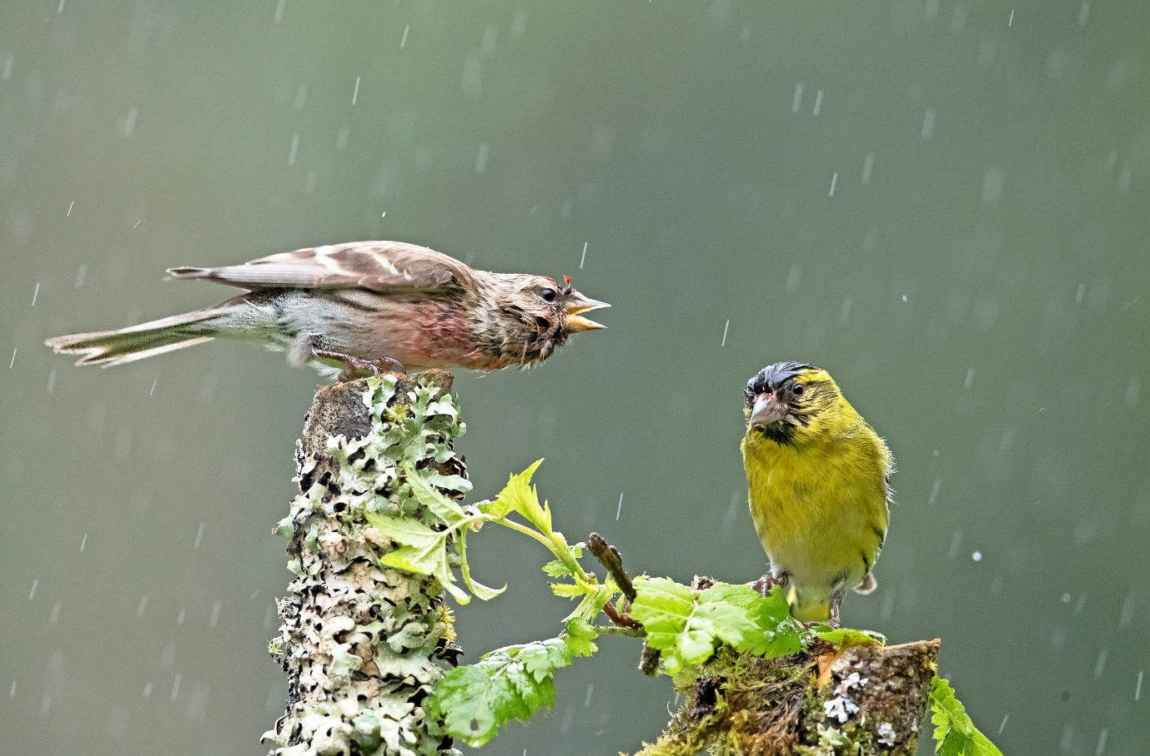
I told you it would rain…
Low light
First, just what is low light? For me it’s a level of light that forces you to choose to either make more light or leaves you having to decide between increased noise or blur in your image. That could mean dusk, dawn or even midday if you’re shooting mainly in the shadows or on a really overcast day. What low light can give you is a softer light much like a studio setup where harsh shadows are eliminated. It also gives you the opportunity to set far longer exposure times which allow you to introduce blur into your images (but that’s another article). I’m not going to cover flash in this article as I never use it for either landscape or wildlife photography which leaves us with the age-old dilemma of noise (or grain as it’s known in film photography) versus the risk of unintended blur. Notice I’ve said unintended blur as I strongly believe there’s a place for intentional blur in both landscape and wildlife photography. For now though I’m going to discuss noise and ‘accidental’ blur below:

Noise
Your camera has a sensor that allows it to capture light and convert what you see through the viewfinder or screen into an image. Think of it as film and you’ll be there. Just like film there are various factors to consider when you’re out there photographing to your hearts content in the gloaming. Noise comes in two flavours; luminance – those lovely grains of noise like the grain in film, or chroma which is the specks and patches of colour you often see when you zoom into an image. There are two points in your workflow where noise is produced – in camera and post-production. Paradoxically they are also the two points where you can substantially reduce noise. It makes far more sense to reduce the amount of noise in camera at the start of your workflow than it does later in the post production stage:

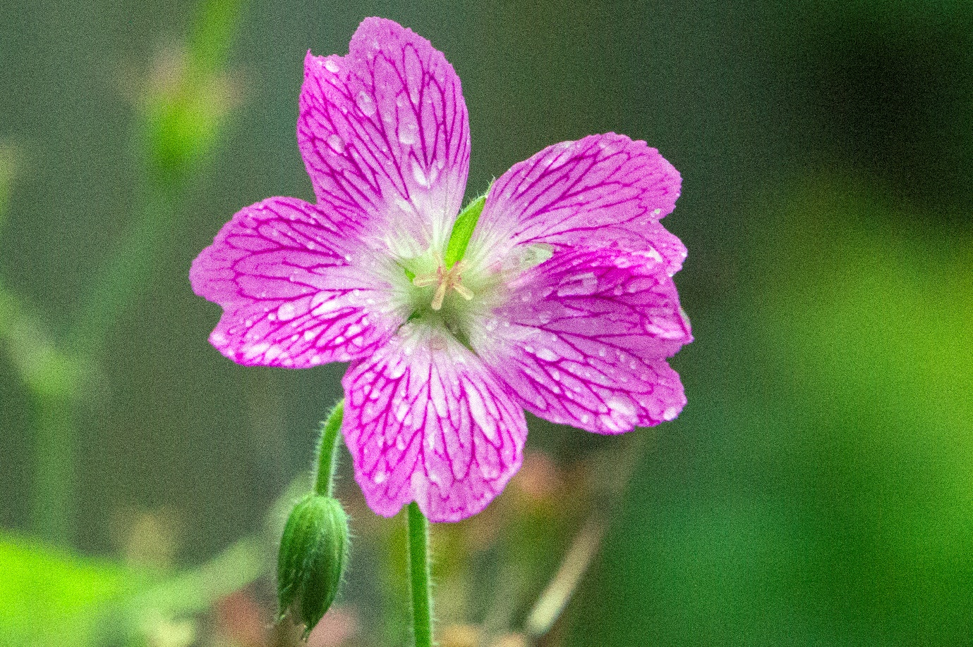
Canon ID MKIV 1/1250th f.9 ISO 12800
In camera noise
All sensors are not created equal
There are a myriad of different sizes, makes and ultimately quality out there. Just because your sensor has x number of pixels doesn’t necessarily mean it’s any better than a higher quality sensor with less pixels. Pixel size is as important as pixel density. Don’t get sucked into the pixel wars without taking a long hard look at the size and quality of the sensor on offer if you’re in the market for a new camera. Larger pixels are more effective as they are more efficient and can hold more light in relation to the noise created by the sensor as it operates – they have a higher ratio of signal to noise meaning you get an appreciably cleaner image. That said some cameras are better than others in low light for other reasons including their ability to work with a higher ISO by utilising in-camera noise reduction software – but this is only relevant to those of you using jpg. Even the lens you use will have some impact on the quality of the final image:
All lenses are not definitely created equal
It’s generally held that a lens shouldn’t affect noise but an emerging theory around the motors, electronics and stabilisers in high end lenses tries to make a case for some kind of interference with the quality of the image, however the main problem with the lens you might be using is the size of its aperture or how fast it is. The speed of any lens is measured by how large the aperture will go to allow light in.
The smaller the f number on your lens – f1.8 for instance – the wider the aperture and the more light can enter. If your lens has an f stop number closer to f4 or f5.6 then you have significantly less light available to you. This means you either have to lower your shutter speed to get the same amount of light as a faster lens = blur, or you raise the ISO = noise. Sadly, the real math that lies behind f stops and the amount of light you can work in often relates more to cost than physics with faster lenses easily costing more than double the price of their slower but equivalent focal length counterparts.
Reducing noise in camera
The easiest way to reduce noise in camera is to keep the ISO down to the lowest setting you can get away with before underexposure or blur kicks in. This may mean using a tripod to allow you to shoot lower shutter speeds or use a flash and/or light painting to increase the amount of light photons hitting your sensor. Other ways of limiting the amount of noise include:
- Avoid underexposure. Exposing correctly in camera means you limit how much noise you’ll introduce during post production as you try to increase the detail in the darks through amplification of the signal.
- Crop as tightly as you can. Use your biggest lens to limit the amount of cropping you might have to do post production. The less you crop the less you magnify existing noise.
- Pick brighter backgrounds over darker ones if you can. Noise likes the shadows. We often have little choice over the time of day we take shots but it’s worth considering delaying a shoot if there’s a brighter day you could just as easily move to.
- I often use bracketing on location. Most cameras will let you take a set number of images in succession with each one slightly different in exposure than the next. Get to know your camera and whether it will let you auto bracket – tripod is best but I’ve successfully taken some very good images by bracing myself against something and kept it all steady. Another method I use is the exposing to the right (ETTR) technique. Here you deliberately aim to over expose to the point the ‘blinkies’ start to come on. Dial back from the highlight alert kicking in and you’ll be left with an image that’s a lot easier to manage the noise with in post production.
- Highly detailed subjects – think feathers, fur and finely textured surfaces - do a great job of absorbing noise. Conversely smooth, less detailed areas like skin, sky and snow can be noise magnets.
When all is said and done you have to ask yourself the question ‘What’s more important to me? Do I not take an image because there might be noise, or is it important enough for me to reduce the noise as much as I humanly can and I’ll deal with what’s left in post production’. I know for me the answer to that is usually the latter – although my recent barn owl project sometimes left me with no option but to let a shot go as the noise levels, despite implementing all of the above, were unacceptable.
Barn owl in low light

Reducing noise post production
There are a raft of noise reduction softwares out there all vying for your hard earned dollar. I personally use Adobe Lightroom and Photoshop Camera Raw but there are plenty of other effective systems to reduce in camera noise ranging from the free DFine 2 from Nik collection through to DxO OpticsPro 11 Elite (around £159). Each has its strengths and weaknesses but overall I think Adobe pips it considering you also get a comprehensive editing suite.
For every software option to reduce noise there are at least three different ways to utilise them. It’s not within the scope of this article to go into great depth about the method that may work best for you but I’ve added links to three very good examples below. There are many more on the web including video tutorials, and I urge you to sit with one or two and give them your full attention for an hour or three and really try to get your head around the concepts and what sits best with you:

http://www.amateurphotographer.co.uk/review/accessory_reviews/noise-reduction-software-test-100814
https://photographylife.com/how-to-avoid-and-reduce-noise
http://f64academy.com/reduce-noise-adobe-camera-raw/
The two side by side before and after pictures below will give you some idea of how your workflow should always include noise reduction using software of some kind:
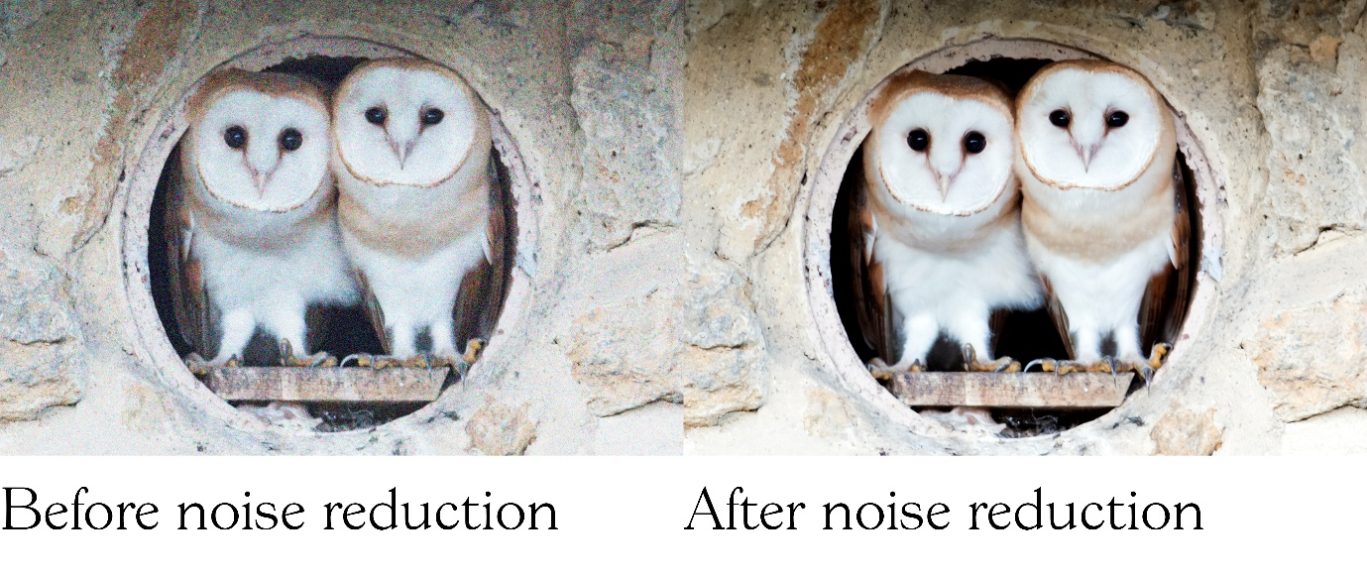
Taken using a shutter speed of 1/15th ISO 2000 f4 on a Gitzo tripod with a 600mm Canon lens utilising a cable release to minimise any camera movement the owls were virtually in the dark when I took this image. Although the ISO isn’t particularly high the amount of shadow and low light around necessitated I shot this using the lowest possible shutter speed to reduce the ISO to 2000. The raw image on the left shows clear signs of luminance and chroma noise which I reduced in Adobe Camera Raw using the system outlined by the f64 academy (link above).

Unintentional blur
As I previously mentioned two things will come back to haunt you in low light photography. We’ve already dealt with noise so let’s lift the lid off the Pandora’s box that is unintentional blur.
There are four main causes of blur in an image. I’ll go through each one below with suggestions to either eliminate blur altogether or at the very least reduce it:

Out of focus
Most modern cameras at just about any level have reasonably good autofocus (AF) capable of tracking a subject and fixing the focus on the point you’ve aimed for. The problems come when, despite your best efforts, you get a very nicely focused image of a chair instead of your gran who was sat in it. One of the major culprits is – you’ve got it – low light. Muted light makes the autofocus on many lenses want to hunt around to find the point of focus. Factor in the many different ways you can set up your autofocus – from using all your autofocus points right through to a single point on many dslr’s and prosumer cameras – and you can begin to see why AF isn’t always the universal panacea to a good shot in low light. Of course, there is a slight chance your lens isn’t microadjusted and could be slightly off centre. To find out if your lens is shooting true you could use a cheap lens calibrator like the one below:
https://www.amazon.co.uk/DSLRKIT-Focus-Calibration-Alignment-Folding/dp/B00SO6IQ5S
Solutions
Try to find a high contrast point to focus on. AF works best in low light if it has something easier to latch on to than a black cat in a coal cellar!
Consider focus and recompose if you’re confident the subject will still be in the same plane of focus and you have enough depth of field.
Manually focus on the subject if you are confident you can focus correctly. Use a penlight or a torch to highlight the subject if it’s appropriate and unlikely to move. Whenever I shoot lightning I use the first good strike to confirm the image is in focus and then I leave the lens on manual for the rest of the shoot. Wide-angle lenses are much more forgiving with manual focus so bear this in mind if you are swopping lenses out or using the zoom.
Make sure you have the AF sensors set to the right parameters for what you want to photograph – I’ve added an excellent article on AF below which explains it in more detail:
http://www.cambridgeincolour.com/tutorials/camera-autofocus.htm
When the shutter is open the subject moves
We’ve all done it. Just stand nice and still until I say you can move. Click, moves and you’re left with this amorphous blob on the review screen. Two things spring to mind here. The first is the shutter speed wasn’t even close to capturing a sharp image. The second is you are probably in Programme or Aperture priority mode where your camera has determined a shutter speed based on the available light rather than the subject’s propensity to would you believe it move. A good way to tell if the subject moved when the shutter was open is to look at fixed unmoving objects in the image. If they’ve remained sharp then the culprit is too slow a shutter speed.
Solutions
Earlier we discussed what must give if you need a certain shutter speed to correctly freeze movement – the exposure triangle as it’s often known as. If shutter speed is x and there’s no wriggle room with x you have three options open to you.
- Create more light- whether that’s with flash, better lighting conditions or repositioning the subject.
- Reduce the depth of field (DOF). Every decrease in f stop gives you double the amount of light and vice-versa. The payback for that is you reduce the distance the subject is in focus with the probable result you’ll still end up with blur – just a different sort.
- Increase the ISO – hopefully by now, if I’ve explained myself well enough, you already know this isn’t a free lunch.
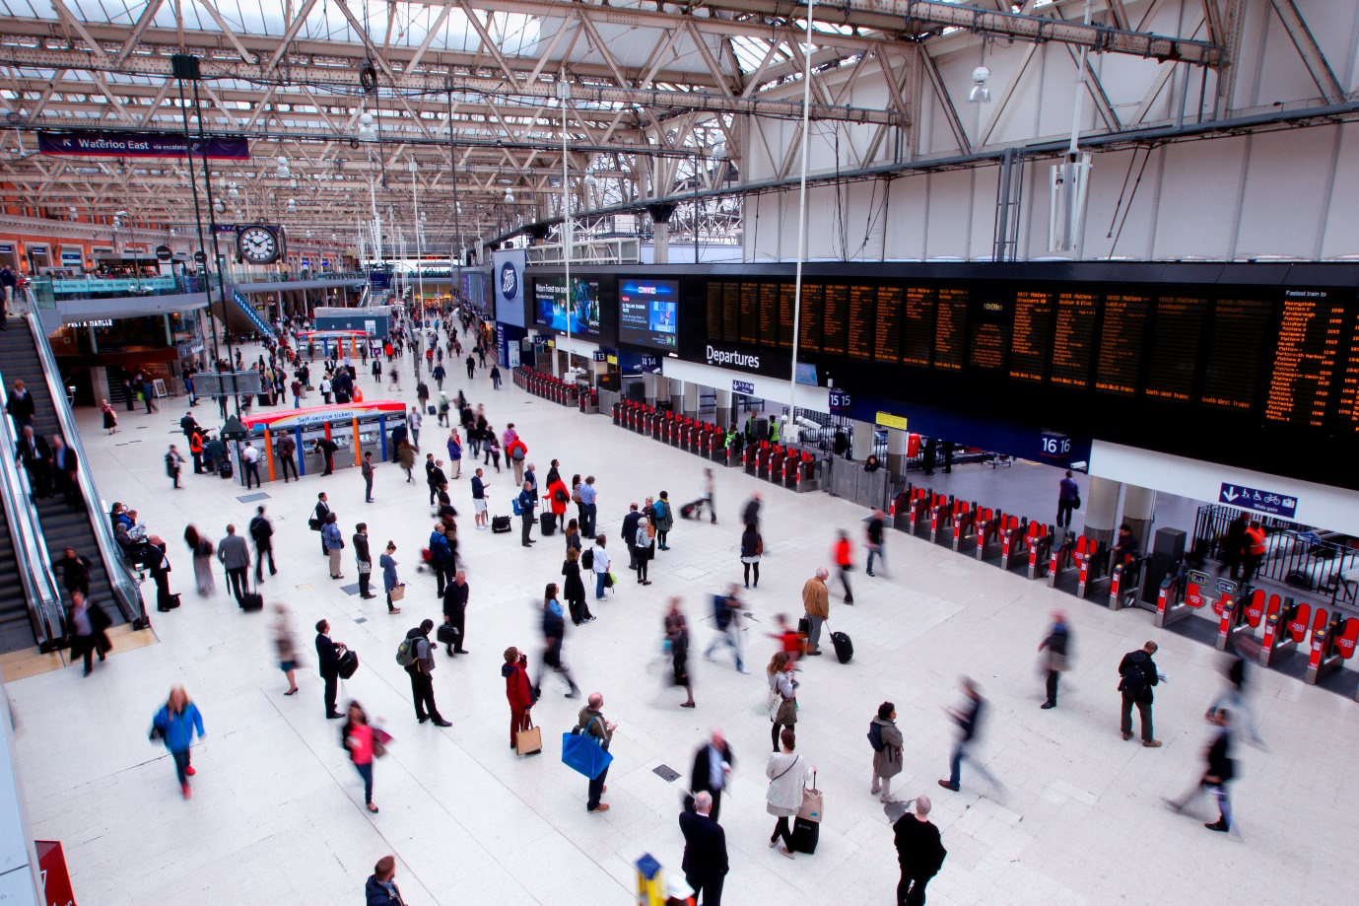
Ten past Ten
When the shutter is open the camera moves
Too slow a shutter speed – whether you’ve personally set it or the camera has – leaves you wide open to the other great blur faux pas of camera blur. Here the subject has remained still as we asked them to. Instead we’ve created the blur by moving the camera slightly either through physical movement or vibration caused by something like the shutter button being released. In this instance you will see the whole image shows signs of blur although often it’s not until you’ve really zoomed in that you realise how soft the actual shot really is. In the example below I’ve taken a picture of my outdoor Buddha which looked reasonably sharp on my review screen (don’t they all). A slight crop later and review it on my laptop screen and it’s clear the image is soft across the entire shot confirming there was camera shake and my shutter speed was too low to be reliably handheld.
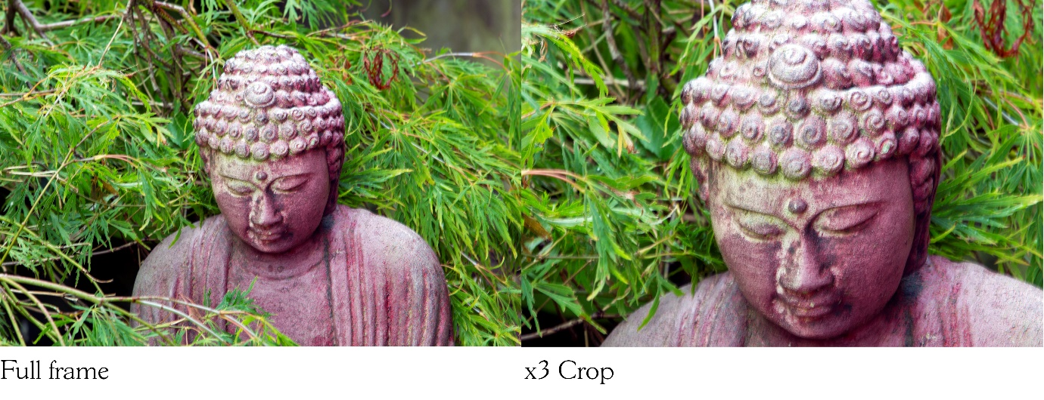
Solutions
- One of the quickest and simplest solutions is to use a tripod and attach a cable release or use the countdown timer. This immediately negates human contact with the camera and leaves it on a solid base. If you can lock your mirror up – assuming you’re not already mirrorless – further potential for camera shake is also reduced.
- If you haven’t got access to a tripod or a shutter release cable try to wedge yourself against something solid, choose the highest shutter speed you can and take several breaths before breathing out and slowly depressing the shutter button. Keeping your camera as steady as possible will limit the amount of times you lose an image to camera shake.
- Wide angle lenses are far more forgiving than prime zooms or telephotos at the extreme end. I know that’s little consolation when the subject you’re shooting is some distance away but if you can use a wider-angled lens or rein the zoom in a bit without increasing the need to crop an image this will also help reduce blur.
- If your camera or lens has a stabiliser then use it. You can gain as much as three stops of light with most systems on a modern camera including bridge, prosumer, mirrorless and DSLR.
Size isn’t everything
Another question you should be asking yourself shooting in low light is ‘what am I going to do with my image?’
There’s a big difference in the apparent noise of an A2 print compared to a small jpg for the web. That’s not to say you shouldn’t shoot with a bigger image in mind, but it’s still a factor to consider. I know I’d rather have a noisy image than a blurred one – especially if it’s a rarity or behaviour I’ve not captured before so be prepared to ramp up the ISO and keep blur at bay. Whilst we’re on size I’d like to ask you what image file system are you using? Is your camera set to raw, jpg or a combo of both? If your camera lets you I strongly suggest you use the raw format. It’s lossless, gives you more data to play with back on the computer, and is far more forgiving than jpg. The downside is it produces bigger files and your memory card and buffer on the camera may struggle. If so then consider upgrading your SD card in terms of speed and capacity. If only jpg is available to you try and use the biggest size your camera will let you. Many modern DSLR’s have auto sharpen software that applies a sharpening process in-camera. It’s not effective when using raw and this software has been known to over-sharpen jpg’s leaving you with jagged edges around your subject. If you only shoot jpg consider the noise reduction software off if you notice your images becoming less sharp.

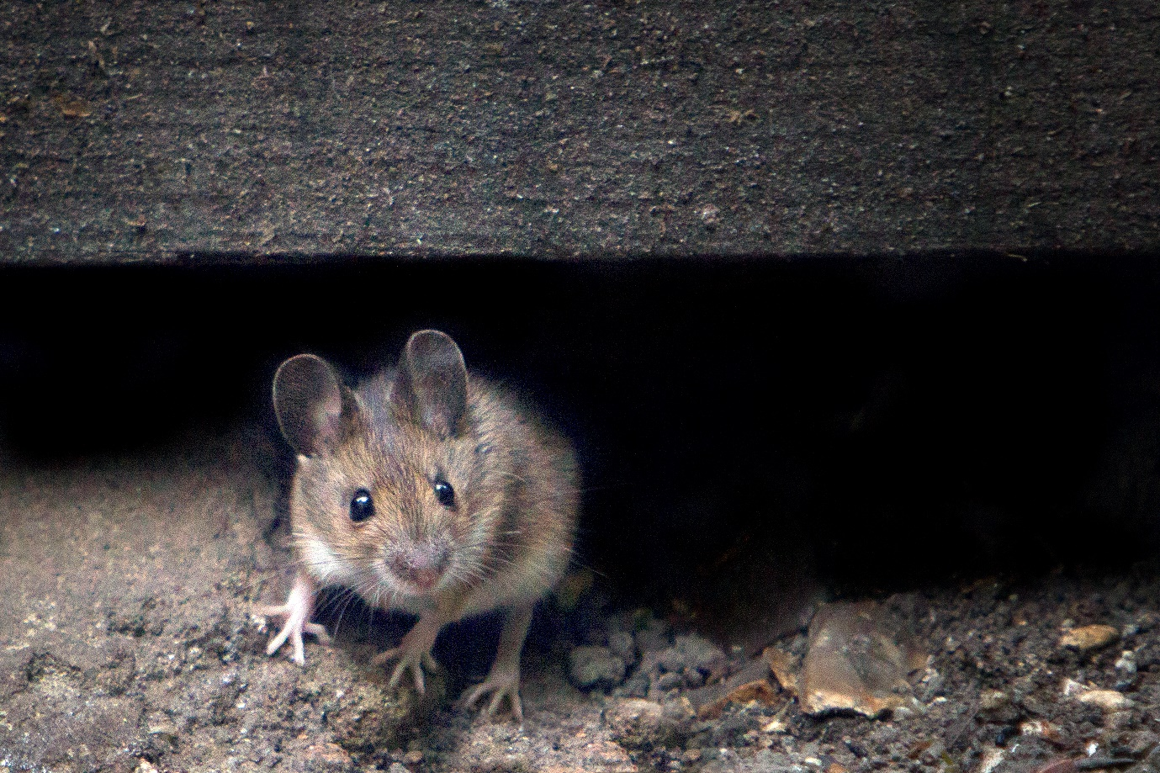
Canon Eos 5D MKIII 70-200mm x2 extender f6.3, 1/200th ISO 3200

Weather
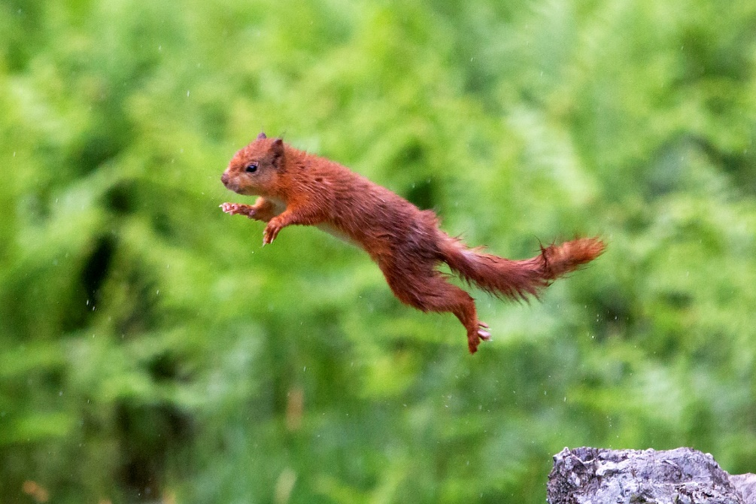
I believe I can fly…
If I never went out when the weather looked a bit ‘iffy’ I wouldn’t have 75% of the portfolio I’ve got. For a start forecasting, despite the multi-million-pound computers used, is still a notoriously inaccurate tool – well it is where I come from. You can have all the weather apps in the world and you’ll still look around you with a bewildered look as the unannounced rain drips off your nose on to your smartphone – it’s rarely the other way in my experience. Perhaps more importantly the knowledge that with certain weather conditions come different photo opportunities holds true. Squally days with sun then rain then back to sun again are some of my favourite days for landscapes. They never fail to surprise me with the quality of the light and I’ve walked back home after those days with a memory card full of rainbows, brooding dark clouds and a clarity of lights and darks you don’t often find. Often the rain itself can be of interest if you use a slow shutter speed as it becomes a faint streak which can add interest to wildlife images. Look out for pools of water reflecting objects and subjects – street photography with neon lights is especially dramatic when rain falls. I remember going in the pouring rain to Castlerigg standing stone circle in the Lake District early one morning in the Fall. Usually busy even at dawn the place was deserted leaving me to wander around and pick my angles without having to hide people behind the stones. The added bonus was the huge puddles of water which reflected the main heel stone and the mountains behind it. The rain even cleared whilst I was there to give me a rainbow over the stones!
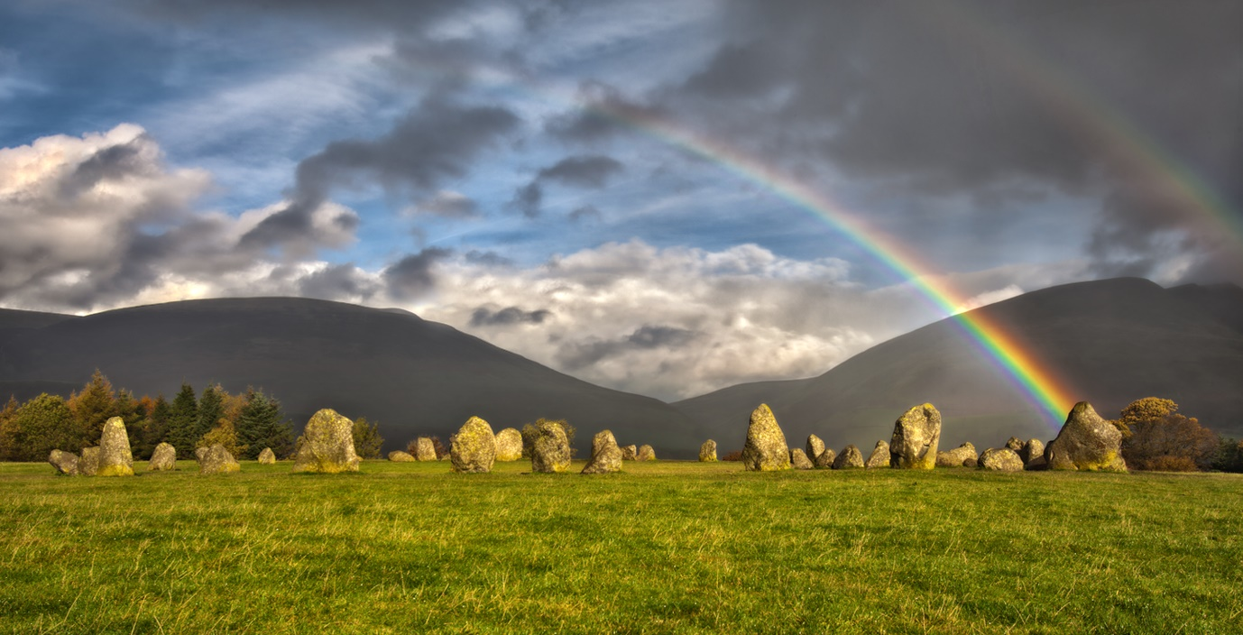
Just need a unicorn…
Rain itself shouldn’t put you off going out and capturing images. Clearly if the rain is being driven at you and your lens it’s a different story to a light drizzle that can be overcome with a rain cover on the camera but for most weather problems there’s usually a solution other than packing up the gear. Let’s look at the various stages of rain:
Overcast
Often called Natures Softbox as the light mimics that from a studio lighting setup designed to minimise shadows and enhance the tones without washing them out like full sun can. Wildlife and people benefit from this kind of light as you’ll avoid the harsh shadows bright sunlight can create and gain improved highlight and shadow detail that flatters the subject. Obviously, there’s a limit to just how overcast it can be before you find it impossible to photograph, but that will be very much down to your skills, the subject in question and the kit you have with you.
Consider
- Portraiture and model work – skin tones often benefit from this kind of light and people are less likely to scowl and squint into the sun or insist on wearing sunglasses leaving you without that valuable eye to eye contact that’s often so important in portrait work.
- Wildlife – feathers and fur often reflect the glare of full sun back leaving the colours muted and somewhat lifeless. Animals and birds are equally highly unlikely to want to squint into the sun so you end up with limited angles from which to photograph your subject.
- Macro – depending on the amount of light available to you macro photography also benefits from this ‘softbox’ effect for the reasons given above. The lighting is natural and even helping to reduce shadows that are even more impactive with smaller subjects. If light levels are just too low to work with then consider a ring flash or a reflector to bounce some light back on to the subject.
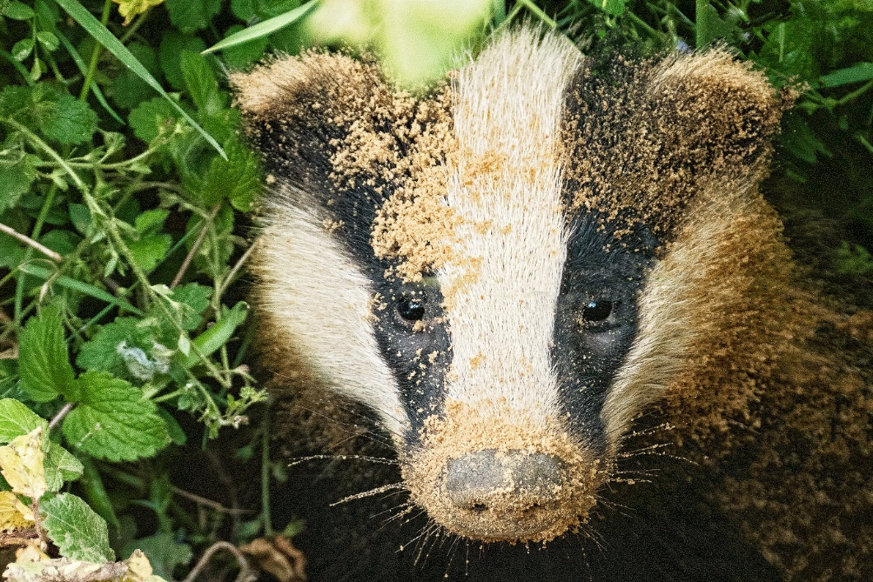
Sandy Badger in low light
Threatening conditions
Not quite as impressive as storms but there’s something about a big bank of black clouds heading towards you as the wind drops and everything holds its breath waiting for the inevitable downpour. With the light behind you and those menacing rain clouds lit up there is huge potential to capture the drama as it unfolds in front of you. Clearly the potential to get very wet very quickly is high so if you can photograph from some kind of shelter like your car or a nearby building, I’d do it.

Consider
- Landscapes – especially if you can get higher up looking across at the weather front rather than up at it.
- Seascapes – looking out to sea is often the first indicator you have bad weather heading towards you. The expanse of sea as a foreground adds more texture and scale to the clouds serving as the background. Try and include a boat or two to create an interaction between humans and the forces of nature.
- Include buildings or people in the frame to heighten the sense of scale.
- Try using the rule of thirds and make the sky two thirds of the image.
- Be aware of the differences in exposure between very dark clouds and well-lit foregrounds – a neutral grad filter is very good at balancing out the exposure differences
- Cityscapes – again the sense of scale with skyscrapers and other buildings set against the backdrop of rainclouds adds impact to your overall image.

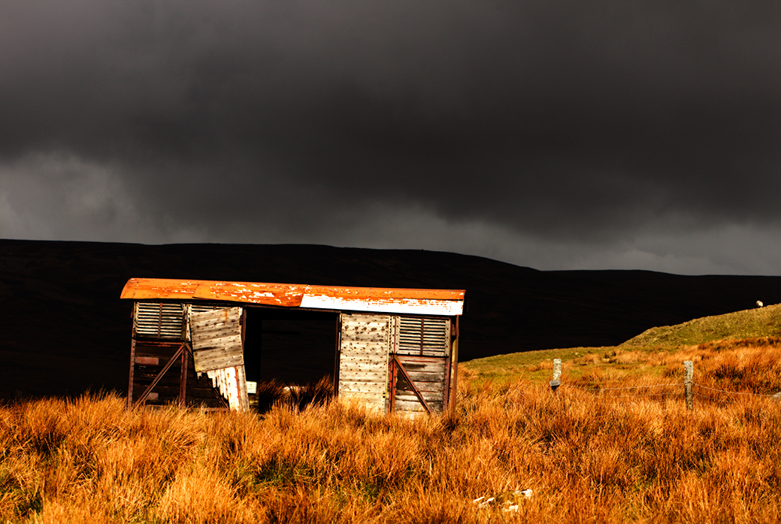 The auld railway carriage on Kirkby moor
Rain
Drizzle
Fine water droplets a lot smaller than raindrops rarely present a problem for the photographer to work in unless it becomes pronounced or lasts for hours. I’d still wear waterproof gear and cover my camera (more on this later) but I’ve found drizzle, even Cumbrian drizzle which tends to sneak through little gaps in your clothing, bearable. Cloud cover tends to be a bit thinner too meaning there’s usually a bit more light around to play with.

Consider
- Macro photography especially plants and insects as the very fine droplets can create an almost bejewelled effect.

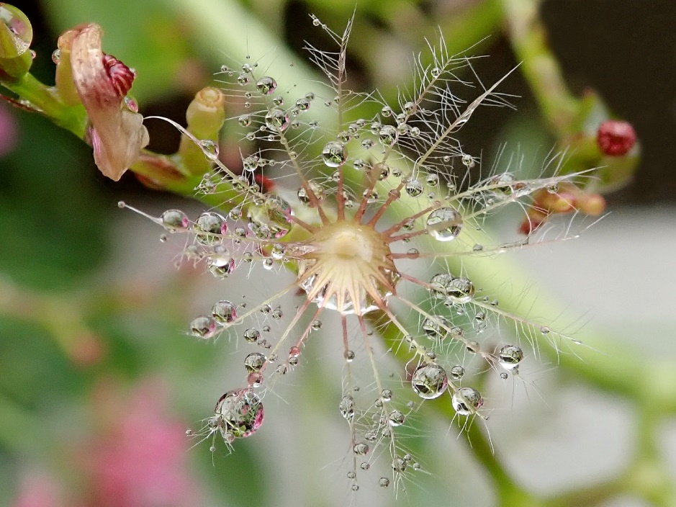
Valerian petal stalk using Olympus TG% - Tough in macro mode
Heavy rain
Yes, it’s not the most inspiring sight in the world. Large drops of the wet stuff plummeting from the sky potentially soaking you to the skin and damaging hundreds, sometimes thousands of pounds worth of electrical equipment. I really can see why it’s a hard one to get your head around but trust me, with the right kit, this article in a waterproof map bag, and some fortitude you too can get out where other photographers fear to tread and capture images you’ll be truly proud of.
Instead of looking at the negatives of rain let’s turn rain into something more positive and consider the benefits it can bring us photographers:
- Busy places suddenly become deserted. That’s a real plus if you want to capture the essence of a location without all those pesky people traipsing around it. Just be prepared for the odd looks from the folks sheltering nearby.
- You get the chance to see reflections where you wouldn’t normally see them. Think busy wet streets bouncing bright neon lights around or bright umbrellas being held by busy people trying to get home.
- Colours become more saturated.
- The sky usually looks a lot more interesting than the pure blue one we occasionally see in the UK.
- Windows become prisms with the raindrops reflecting and bouncing light and images around in an abstract way.
- You don’t get rainbows without rain. I personally am still amazed when I see one and always want to capture it in all of its seven-colour glory.
Consider
- Street photography - Busy wet people with brollies, kids splashing in puddles, bright raincoats and reflections everywhere. Candids are often easier as people are focused on staying dry and not you pointing your lens at them.

- Landscapes – Skies are usually more dramatic and everything has a slight sheen to it which enhances colours and brings out texture. Waterfalls and rivers become fuller and more striking. Roads become rivers as the tarmac gets wetter and foliage has an added layer of interest to it with raindrops clinging grimly to the leaves and branches.
- Wildlife – many animals and birds will have a good shake once the rain reaches a certain point on their fur or feathers. With the right shutter speed (think nice and high) you can capture every drop as they try to dry themselves off.
- Macro – if the rain isn’t belting down and you can find individual drops on plants or trees macro photography of drops can be fascinating as you capture the world behind the drop in miniature – albeit upside down.
- Pre-focus and set up the exposure in a dry place so the camera is out for the minimum time necessary to get the shot(s).
- Carry a few microfibre cloths with you to wipe the body down and clean the lens for those times when the rain is wind-driven and quickly affects image quality or risks the integrity of the electronics.
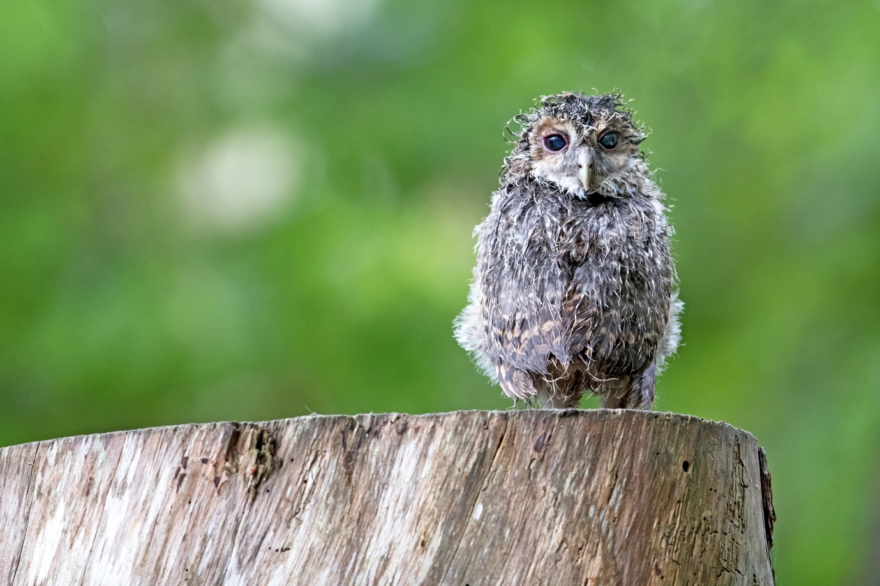
Tawny owl has lost his happy
Storms
My name is Paul and I’m a storm-chaser. There. It’s out and I feel better for it. I love them. I love being out in all that elemental energy with the technical and physical challenges they present to me as a photographer. For me the benefits far outweigh the negatives – although to be fair I have some excellent wet weather clothing and camera gear. The main point to bear in mind with storms is their unpredictability. Oddly enough lightning and metal photography kit have a bit of an affinity for each other. Factor in being the tallest thing standing on the blasted heath and it doesn’t take Einstein to realise this is a potentially dangerous pastime. I’ve had lightning arcing over my head and striking behind me which is a tad troubling as I’ve got metal plates in my ankles from a climbing accident and a lovely carbon fibre tripod with a huge DSLR on the top…

- Consider a lightning app like Lightning Radar if you’re serious about storm chasing. They show you real time strikes with the distance and frequency on a map tuned to your location.
- Invest in a stable (read heavy) tripod – the best you can afford. You’ll need it for all the other nice things I’ve already mentioned above so buy a good one. An effective tripod isn’t affected by high winds and often has a hook hanging from it enabling you to hang a rucksack or something equally heavy to hold it even steadier.
- I have an Olympus TG5 – Tough camera. It’s waterproof to 15m, shockproof (I have a history of falling off cliffs with my camera in hand), dustproof and pocket-sized. Because its waterproof and shoots 4k video along with a host of other wonderful options I had no hesitation in putting it out in the last big storm I covered a few weeks ago. It got soaking wet but it’s designed to so I was able to shelter by a building and let the Olympus do its thing without getting too wet or stressed about it being out there.
- Either buy or make a waterproof cover for your camera. There are dozens out there and most of them are relatively inexpensive. Go for the ones with elasticated sleeves that sit tight at the end of your lens and make sure it opens wider at the camera body end so you can still see the controls. A plastic bag with some elastic bands is a great stopgap if you find yourself out in the rain and still want to shoot.
- Most lenses come with a lens hood – the plastic thing a lot of people leave in the box. It should be permanently on rain or shine. It’s designed to shade the lens so your exposure meter is more accurate, protect the lens from light flare and reduce the potential for scratches to the lens coating. It’s also very good at stopping some of the rain from being driven across the lens face if you have the wind against you (it’s always against you).
- Use a wide-angle lens to maximise the amount of sky you can cover. Try the Bulb setting and hold open the shutter for around 30 seconds using a cable release or similar. Be prepared to use Manual and experiment with different apertures and ISO levels to get the best setting to capture lightning. My approach is to use Bulb on Manual and take several test shots until I’m happy the exposure is about right for those big bolts of lightning. I then run the camera on 30 second exposures with no gap in-between to gawp at the screen. I’ve either got the shot or not so there’s no point in missing valuable time whilst the storm rages if you’re happy the exposure values are already right.
- No shot is ever worth risking your safety for – a bit rich coming from the bloke who’s fallen off cliffs into the sea and got about a dozen scars from various adventures and assorted shenanigans – but you know what I mean. Risk assess your location, let people know where you’re going to be and what time you aim to get back, and keep a permanent eye on the storm’s path and the pattern of the lightning to see if it’s moving closer to where you are.
Consider
- Landscapes – nothing changes a landscape more dramatically than a storm especially at night. Try to pick a location that not only offers you some degree of protection from the rain and lightning but also a building or monument of interest. Lightning on its own, although amazing, nearly always look better when there’s something else sharing the image with it.
- Cityscapes – there are some jaw dropping shots of lightning and storms hitting our major cities across the globe. Some of the best locations are up high and overlook the city. If you’re really lucky, you’ll find a place that lets you sit in the car and shoot to your hearts content whilst staying dry.
- Seascapes – one of my favourite places to shoot storms is the Isle of Portland just off the Dorset coast. It’s got an iconic lighthouse and a small café with a veranda that affords you some shelter from the wind and rain. You also get a nearly 280-degree view of the horizon which gives you a good heads up which direction everything is travelling and where the most strikes are going in.
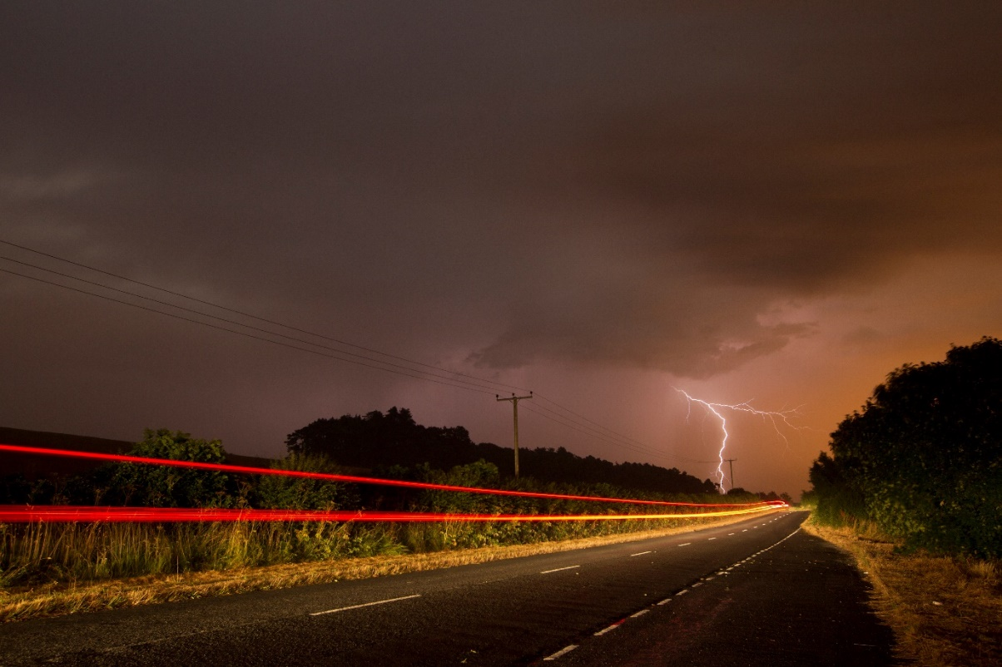
When light meets light
There are of course other types of weather in dear old Blighty; sunshine, snow, the occasional faint zephyr, but at the risk of this article becoming longer than the EU policy on the size and shape of carrots I’m going to stop at rain. Further articles may well come along in due course.
Equipment
Camera and lenses
It’s an indisputable truth that some cameras are better than others in the rain. Putting aside the specialist adventure cameras like my Olympus TG5 – Tough each manufacturer has provided a range of cameras for us the consumer to choose from according to our perceived needs as a photographer. For some it’s portability and for others it’s how robust they might be in the big, often bad outdoors. At the root of all of it will be cost. Putting double seals, solid aluminium bodies and water-resistant lenses into the mix costs money so you and I have to make decisions around what kind of photography we want to do. For me it has always been about landscapes and wildlife. I don’t do weddings, people, kids, PR work or events. My needs as an outdoor photographer substantially differ from say my friend the wedding photographer, or my other friend the portrait and press specialist.
Add the kind of skill level you might be at or aspire to be at, how often you plan on doing photography, your physical ability to carry heavy kit some distance and a dozen other criteria and you start to see how complicated making these often-expensive decisions can become.
There is a point to me rambling on. I want you to think long and hard about your decision making when it comes to photographic gear. Are you able to project forwards and see where you might be in a year or two’s time? Do you need a DSLR with full weatherproofing or will your bridge camera with a good camera bag be enough to achieve what you set out to do?
I research every bit of camera gear I buy then research it again. I look for weaknesses, complaints, plaudits and comprehensive reviews that show the same results.
Talk to other photographers about their experiences with their equipment – there’s no substitute for real world testing of camera kit and the opinion of those who’ve spent a day or three in the rain with it. Once you’re out for the day you don’t want to be heading back home an hour later because your kit has let you down – even less so if you’ve just tabbed however far up a mountain or along a valley to get to a location. I’ll finish with this:

There are DSLR’s and lenses out there I wouldn’t even take out of the bag if rain was due, and yet there is kit I’ve personally more or less immersed in water and it has continued to work as effectively as it would have done on a bright sunny day – the exception being the MKIII I fell in the sea with… ahem. Equally there are bridge cameras, point and shoots, mirrorless, micro 4/3rds and on and on that will do a perfectly good job in light rain if you apply a little common sense and some of the tips I’ve included in this article.
- Camera coats or covers are a relatively inexpensive way of keeping your gear dry, although there’s nothing to say you don’t hide your camera under your coat and whip it out to take a shot and then put it back again – it’s just a lot more faffy.
- You can get golf umbrella brackets that fit on your tripod and which will allow you to have a large brolly to work under – just gauge the strength of the wind before you put it all up as you don’t want to be doing a Mary Poppins with all your gear airborne.
- Use the lee of buildings, walls and trees to shoot from if possible.
- Be prepared to review your images and look closely for distortions that might indicate you’ve got rain on the lens. Microfibre cloths are essential but keep them away from grit as all you’ll do the next time you clean your lens is scratch the coating.
- Sounds obvious but changing your lens in wet conditions is just asking for moisture to get past those lovely seals the manufacturer put in to keep that very same moisture out. If you have to change a lens find a dry place, wipe every speck of rain around the lens mount and the camera body. Once you’ve changed lenses give the lens you’ve taken off a good drying off with a microfibre cloth.
- Silica gel (the little bags with do not eat ‘Silica Gel’ on them) can be put into a plastic bag along with a damp lens or camera body and will have some effect on reducing both the moisture on the kit and any condensation it might produce.
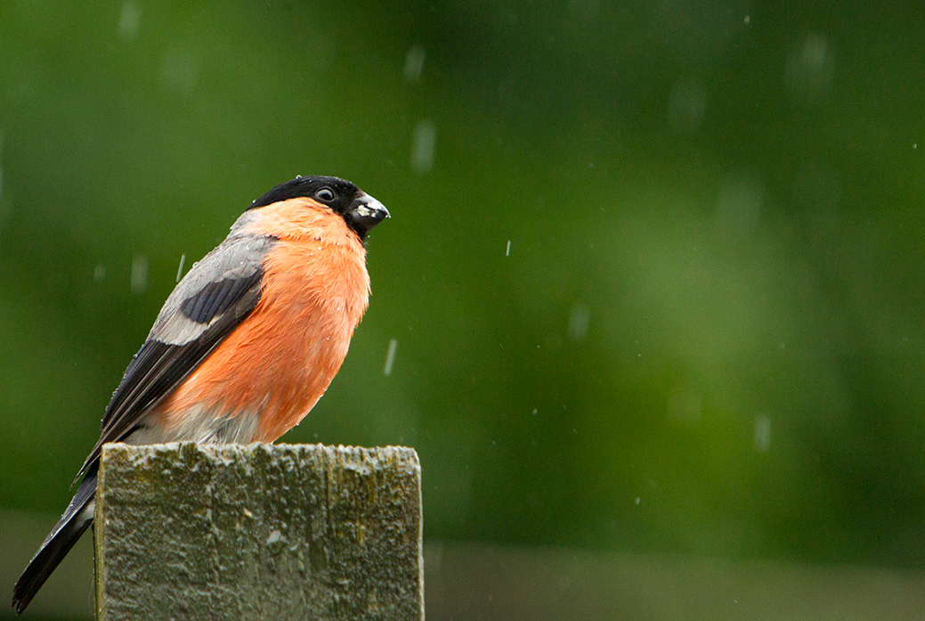
Bullfinch in the rain
Camera bags
The choice of camera bags to put our beloved photography gear in is more or less limitless. You can spend as little as a tenner or you can easily hit £400 and beyond. I’ve found the same rules apply as for when you’re looking at buying camera gear – research, research, compare and ask questions. I want a bag that’s ergonomically comfortable, can be easily rearranged internally to suit the day’s shoot and what I need to carry as well as being well made and good value (I don’t ask much do I). The very least it should have is a rain-proof cover you can pull out and pop over the weather-facing aspect of the bag. Better still if you can afford it a waterproof bag along with a rain cover and watertight zips would be my bag of choice.
It needs to be big enough to get everything you want in – and then a little bit more as life as a photographer has a habit of throwing more and more gear at you – as well as red squirrels. I’ve added a link to a nice review on camera bags below:
https://shotkit.com/best-camera-bags/
Because everyone loves Canon gear…
Clothing
My first question here is do you need clothing that’s specific to photography i.e. a photographer’s vest or jacket such as Billingham or Stealth Gear, or do you want generic clothing capable of keeping out the worst of Britain’s weather? Thankfully manufacturers have cottoned on (sorry) to our dilemma and hybrid garments are appearing on the market as I type. Perhaps the best known of those is Paramo’s Halcon and Pajaro jackets which combine ample space for spare bodies, lenses and all the other assorted paraphernalia we like to carry with the practicalities of a waterproof, windproof and rustle-free fabric. My second question is related to the type of photography you intend to do. For instance, there’s little point in buying that rather fetching little Gore-Tex number in saffron if you plan on looking for Golden Eagles up in the Cairngorms. As obvious as it sounds your clothing should meet every photographic need for your type of photography. My gear is waterproof, olive green or black, breathable, windproof and hard-wearing. I use a combination of Paramo (windproof, showerproof smock), Arcteryx (technical waterproof and breathable jacket) and Keela (Scuffer walking trousers) which, along with my Salomon GTX boots permanently on my feet, leaves me good to go in most conditions other than 30 degrees of sunshine!
Come the winter months I ramp up the layers including an Under Armour thermal vest, fleece lumberjack shirt, North Face gilet and Thinsulate gloves and beanie. Sounds like a lot of layers? It is but until you’ve stood still for nearly three hours on Portland in January waiting for short-eared owls to appear then I’d ask you to keep an open mind.
- Pick clothing suitable for the job in hand. If it’s wildlife choose muted colours like olive green or black. My personal view of full camo gear for much of what we shoot is it’s often overkill and no substitute for good fieldcraft and the ability to keep still for long periods of time.
- Anyone can be cold and/or wet. Think your day through and have extra kit packed away in the car or in your rucksack if you have room. It’s far easier to take something off and cool down than it is to sit there shivering because you’ve got wet or the wind is whistling through the two layers you have on.
- Think strategically. If your thing is street photography do you really want to look like a photographer out hunting its human prey? Blending into any environment whether it’s urban or rural is important on lots of levels – personal security and stealth being just two of them.
- By all means don’t fret about brands. There are plenty of cheaper alternatives to the main players out there – but you generally get what you pay for. My GTX walking boots are pricy when you look at the initial outlay but five years on of literally daily wear they are still going strong and keeping my ankles supported and feet dry. Over those five years they’ve worked out at less than a cheap pair from (insert any name you care to choose) that last less than a year – oh go on then, six months.
Hopefully I’ve given you a little bit of insight into my world as an experienced wildlife and landscape photographer used to dealing with all kinds of light and weather. Many of the hints and tips in this article are based on my experiences and have been hard won and tried and tested many times in the most adverse of conditions. Ultimately the proof of any pudding is the result you see before you and I’m pleased to say most of my images come out pretty well given the minimal light and maximal rain I usually have to deal with.
I welcome any questions or suggestions the article may have unleashed and you are welcome to contact me via my email paul@paulwilliams.photography or via my Facebook page below:
https://www.facebook.com/paulwilliamsphotographer/
I’ll leave you with a few images I wouldn’t have in my portfolio if I hadn’t gone out in the rain:
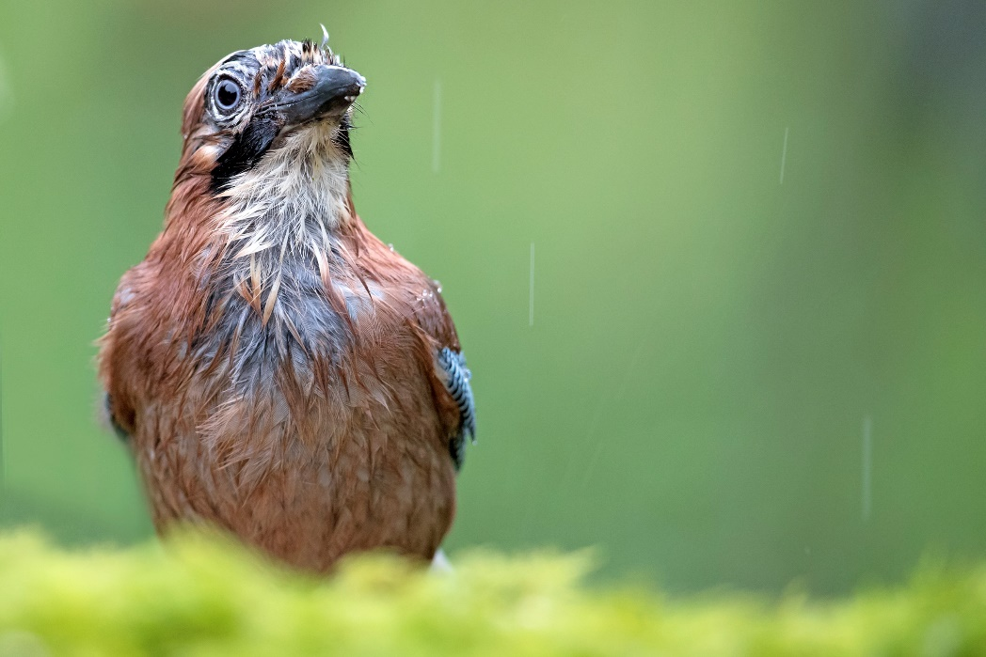
A wet day watching a wet Jay…
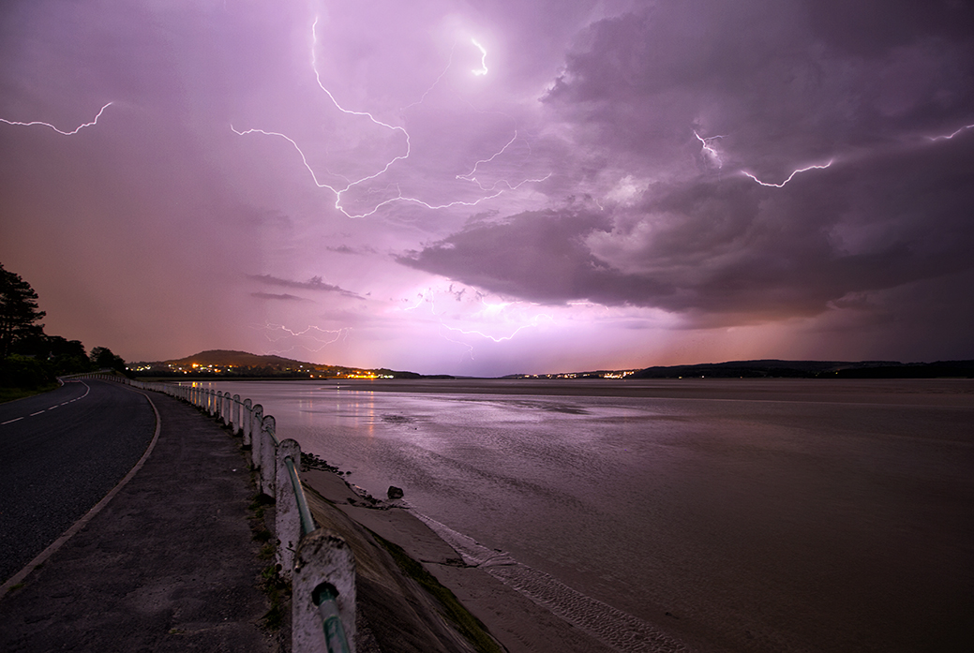
A night out in Arnside
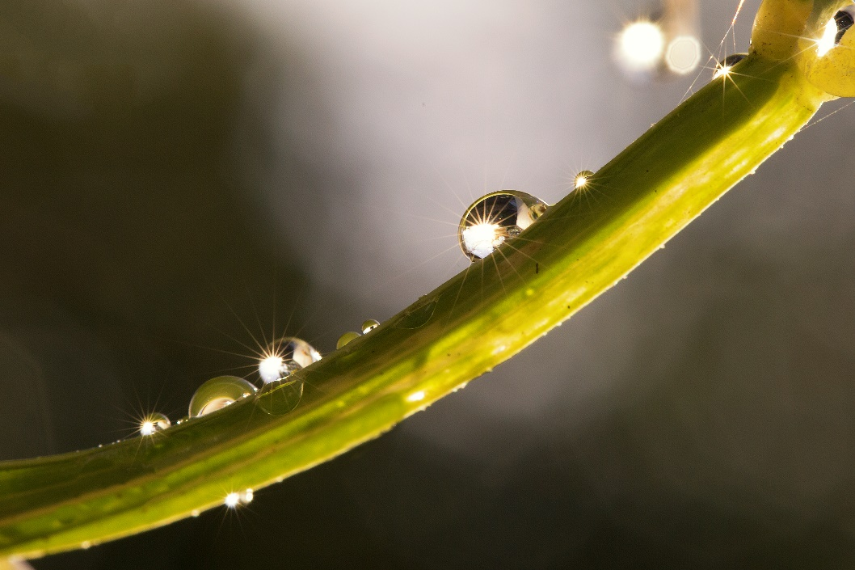
Worlds within Worlds II
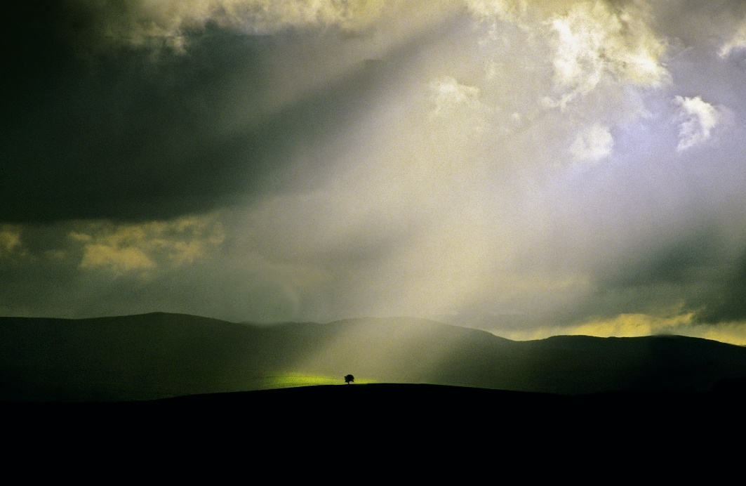
Lone Tree V
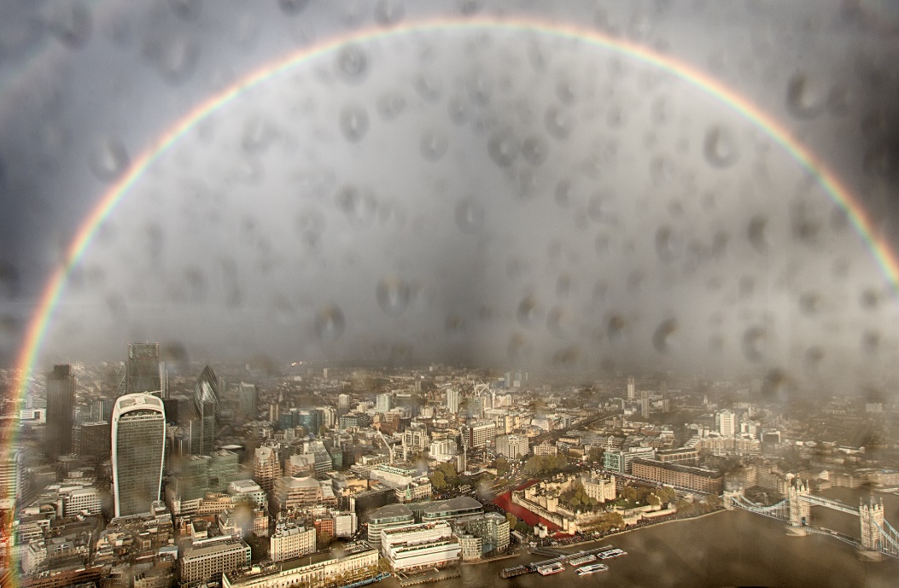
Storm from the Shard

